Civil war in Sierra Leone

UNSC Resolution: | 1508
Date of adoption: | 19 September 2003
Operative paragraph: | 4
Demand number: | 2

Megan MacKenzie

Wording of demand

accelerate the consolidation of civil authority and public services throughout the country, and continue to strengthen the operational effectiveness and capabilities of the security sector

List of addressees of the demand

Government of Sierra Leone

Short-term compliance

Description of the addressee(s)’ conduct

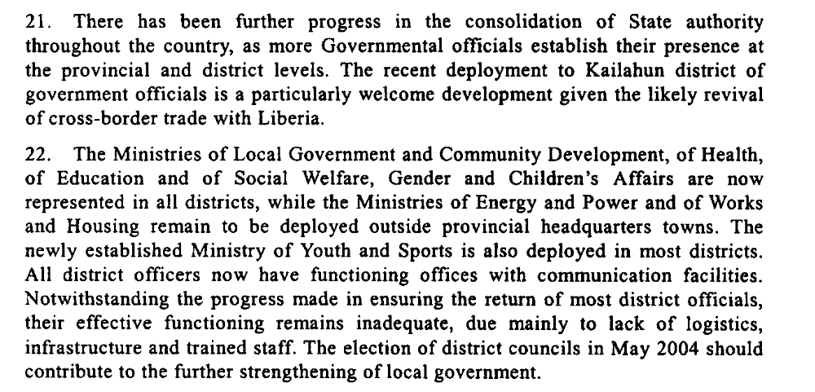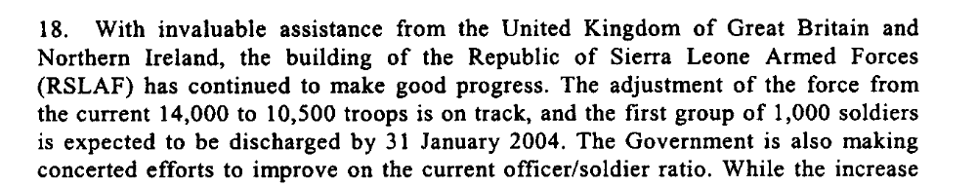

Assessment

Short-term compliance
No or marginal compliance (1) | Medium low compliance (2) | x Medium high compliance (3) | Full or almost full compliance (4)

Considerations underlying the assessment

Clear steps had been taken to consolidate state authority across the country; however, these efforts had some limitations, particularly in terms of logistics.

Medium-term compliance

Description of the addressee(s)’ conduct

46. The Government of Sierra Leone has made commendable efforts to enhance the control of diamond mining, which has resulted in a considerable increase in revenues from official diamond exports. This achievement constitutes one of the key outcomes of the consolidation of State authority across the country. The authorities should be encouraged to continue further strengthening their control over this sector, which is essential for the revitalization of the national economy.
17. In collaboration with the World Bank and UNDP, the Government of Sierra Leone has carried out a training and capacity-building programme to enhance the effectiveness of the newly elected local authorities. A review of local tax rates by the local councils, in collaboration with chiefdom authorities, is under way. In the current economic situation, however, the prospects for significant public revenues to be generated for funding basic services remain poor.
44. Nonetheless, the lack of infrastructure and adequate equipment continues to hamper the operational effectiveness of the national security sector, most particularly in the border areas. Recent donor support, in particular the pledge of the Government of Switzerland to donate 260 assorted trucks to the Sierra Leone Armed Forces, as well as the continuing major support by the United Kingdom, has been most helpful. However, much more remains to be done towards strengthening the operational capacity of the police and armed forces. In view of this, the Government and its international partners should intensify efforts aimed at addressing the infrastructure and logistical needs of the Sierra Leone security sector.

Assessment

Medium-term compliance
No or marginal compliance (1) | Medium low compliance (2) | x Medium high compliance (3) | Full or almost full compliance (4)

Considerations underlying the assessment

The Government had been commended on its progress in extending its authority throughout the country. A lack of resources remained a drawback to this progress.

Depth of demand

Assessment

Level of depth of demand
x Low depth of demand (1) | Medium depth of demand (2) | High depth of demand (3)

Considerations underlying the assessment

Level of confidence about coding decisions

Level of confidence about coding decision
Extremely high | x High | Moderate

Comments to IPI (if any)

Civil war in Sierra Leone

UNSC Resolution: | 1508
Date of adoption: | 19 September 2003
Operative paragraph: | 5
Demand number: | 1

Megan MacKenzie

Wording of demand

continue to strengthen its control over, and regulation of, diamond mining, including through the High Level Steering Committee

List of addressees of the demand

Government of Sierra Leone

Short-term compliance

Description of the addressee(s)’ conduct

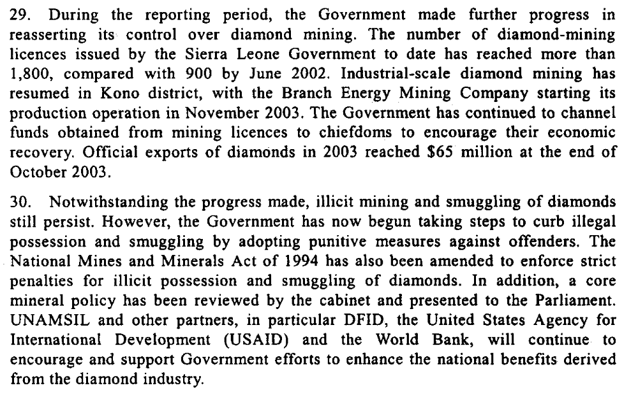

Assessment

Short-term compliance
No or marginal compliance (1) | Medium low compliance (2) | x Medium high compliance (3) | Full or almost full compliance (4)

Considerations underlying the assessment

The Government was made clear efforts to monitor and control the diamond industry during this time. Although illegal sales continued, the Government continued to try to develop means to regulate this industry.

Medium-term compliance

Description of the addressee(s)’ conduct

46. The Government of Sierra Leone has made commendable efforts to enhance
the control of diamond mining, which has resulted in a considerable increase in
revenues from official diamond exports. This achievement constitutes one of the key
outcomes of the consolidation of State authority across the country. The authorities
should be encouraged to continue further strengthening their control over this sector,
which is essential for the revitalization of the national economy.
20. The Government has continued to make progress in expanding its control over
diamond mining. By the end of October, revenues from official diamond exports had
reached $120 million, compared to $71 million during the same period in 2003. This
is largely attributed to the Government’s consistent implementation of the
Kimberley Process Certification Scheme. A Kimberley Process peer review visit to
Sierra Leone and Guinea is scheduled for early in 2005, to address regional
initiatives to prevent the illicit trading and smuggling of diamonds.

Assessment

Medium-term compliance
No or marginal compliance (1) | Medium low compliance (2) | Medium high compliance (3) | x Full or almost full compliance (4)

Considerations underlying the assessment
Despite the challenges to complying with this demand, the Government made considerable efforts. In particular, the Kimberly process was largely seen as a success.

Depth of demand

Assessment

Level of depth of demand
Low depth of demand (1) | x Medium depth of demand (2) | High depth of demand (3)

Considerations underlying the assessment

Level of confidence about coding decisions

Level of confidence about coding decision
Extremely high | x High | Moderate

Comments to IPI (if any)

Civil war in Sierra Leone

UNSC Resolution: | 1508
Date of adoption: | 19 September 2003
Operative paragraph: | 8
Demand number: | 4

Megan MacKenzie

Wording of demand

resume dialogue [between the Presidents of the Mano River Union member States] and implement their commitments to building regional peace and security

List of addressees of the demand

Government of Sierra Leone

Short-term compliance

Description of the addressee(s)’ conduct

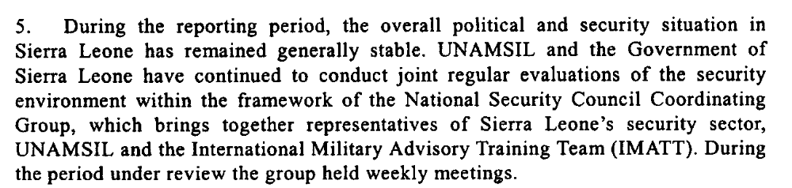

Assessment

Short-term compliance
No or marginal compliance (1) | Medium low compliance (2) | Medium high compliance (3) | x Full or almost full compliance (4)

Considerations underlying the assessment

This was a period characterized by peace and stability and continued efforts by the Government to maintain this stability.

Medium-term compliance

Description of the addressee(s)’ conduct

The situation has remained generally calm and stable in Sierra Leone over the reporting period. The favourable security environment has facilitated further progress in the consolidation of peace in the country and has also enabled UNAMSIL to proceed with the continued drawdown of its military component. Furthermore, it has been possible for the Mission to transfer the overall primacy for security responsibility in the country to the Government of Sierra Leone.

Assessment

Medium-term compliance
No or marginal compliance (1) | Medium low compliance (2) | Medium high compliance (3) | x Full or almost full compliance (4)

Considerations underlying the assessment

There were no major incidents of violence during this period, and the Government of Sierra Leone maintained their commitment to peace and stability.

Depth of demand

Assessment

Level of depth of demand
x Low depth of demand (1) | Medium depth of demand (2) | High depth of demand (3)

Considerations underlying the assessment

Level of confidence about coding decisions

Level of confidence about coding decision
Extremely high | x High | Moderate

Comments to IPI (if any)

Civil war in Sierra Leone

UNSC Resolution: | 1508
Date of adoption: | 19 September 2003
Operative paragraph: | 9
Demand number: | 1508.0912

Megan MacKenzie

Wording of demand

maintain intensive patrolling of the border with Liberia

List of addressees of the demand

Government of Sierra Leone

Short-term compliance

Description of the addressee(s)’ conduct

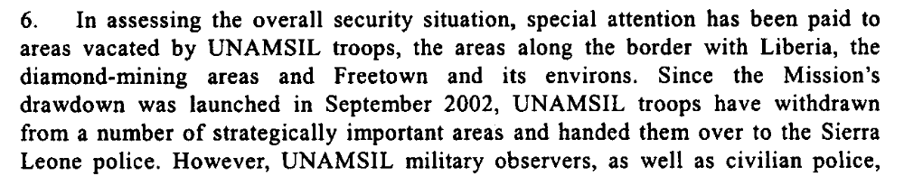

Assessment

Short-term compliance
No or marginal compliance (1) | Medium low compliance (2) | x Medium high compliance (3) | Full or almost full compliance (4)

Considerations underlying the assessment
As UNAMSIL drew down, the Government of Sierra Leone dedicated resources and attention to monitoring the border with Liberia.

Medium-term compliance

Description of the addressee(s)’ conduct

4. The relationship between the Republic of Sierra Leone Armed Forces and the
Sierra Leone police continued to improve, as the leadership of the two security
agencies committed themselves to enhancing cooperation, as stressed in their joint
communiqué of 9 August. In addition, joint operations undertaken recently by the
two entities, particularly in the border areas, have helped to foster better tactical
coordination between the security forces.
6. There have been no major external threats to the security of Sierra Leone
during the period under review. The situation in Liberia has continued to stabilize,
despite the recent disturbances in Monrovia. In addition, the security situation on
the border with Liberia has improved with the deployment of the United Nations
Mission in Liberia (UNMIL) and also the deployment of immigration officials from
the National Transitional Government of Liberia at major border crossings. Joint
border patrols by the Sierra Leone police and armed forces have increased with the
support of UNAMSIL.

Assessment

Medium-term compliance
No or marginal compliance (1) | Medium low compliance (2) | x Medium high compliance (3) | Full or almost full compliance (4)

Considerations underlying the assessment
With the help of UNAMSIL, the Government of Sierra Leone maintained intensive monitoring of the border with Liberia.

Depth of demand

Assessment

Level of depth of demand
x Low depth of demand (1) | Medium depth of demand (2) | High depth of demand (3)

Considerations underlying the assessment

Level of confidence about coding decisions

Level of confidence about coding decision
Extremely high | x High | Moderate

Comments to IPI (if any)

United Nations Secretary-General. Twentieth Report of the Secretary General on the United Nations Mission in Sierra Leone. 23 December 2003.
United Nations Secretary-General. Twenty-fourth Report of the Secretary General on the United Nations Mission in Sierra Leone. 10 December 2004.
United Nations Secretary-General. Twentieth Report of the Secretary General on the United Nations Mission in Sierra Leone. 23 December 2003.
United Nations Secretary-General. Twenty-fourth Report of the Secretary General on the United Nations Mission in Sierra Leone. 10 December 2004.
United Nations Secretary-General. Twentieth Report of the Secretary General on the United Nations Mission in Sierra Leone. 23 December 2003.
United Nations Secretary-General. Twenty-fourth Report of the Secretary General on the United Nations Mission in Sierra Leone. 10 December 2004.
United Nations Secretary-General. Twentieth Report of the Secretary General on the United Nations Mission in Sierra Leone. 23 December 2003.
United Nations Secretary-General. Twenty-fourth Report of the Secretary General on the United Nations Mission in Sierra Leone. 10 December 2004.

